**SEM**

Search engine marketing (**SEM**) is a form of Internet marketing that involves the promotion of websites by increasing their visibility in search engine results pages (SERPs) primarily through paid advertising.

Search Engine Marketing is a process in which you market your business or product by using the available paid advertisements of various search engines.

You can bid on the keywords that you want your ads to get displayed in the search engines.

Search Engine Marketing is also known as paid search or pay per click (PPC).

These advertisements come in a variety of formats ranging from small text ads to visual Ads

Do you find difficulty in promoting your business online because of the increased competition in the marketplace?

Yes? Actually millions of businesses and companies come online every day and most of them have the same goals.

It’s never been so important to advertise online in order to be ahead of your competitors in the past few years.

So if you want to advertise your online business, “**Search engine marketing**” is the most efficient method to promote your products or services online.

In this article, I will give you each and every detail of search engine marketing and what are the strategies involved in this kind of marketing to promote your online business.

## **What Is Search Engine Marketing?**

According to [Wikipedia](https://en.wikipedia.org/wiki/Search_engine_marketing) Search Engine Marketing can be defined as.

Search Engine Marketing is a process in which you market your business or product by using the available paid advertisements of various search engines.

You can bid on the keywords that you want your ads to get displayed in the search engines.

Search Engine Marketing is also known as paid search or pay per click (PPC).

These advertisements come in a variety of formats ranging from small text ads to visual Ads.

# SEM (PPC) Vs. SEO: What’s The Difference?

[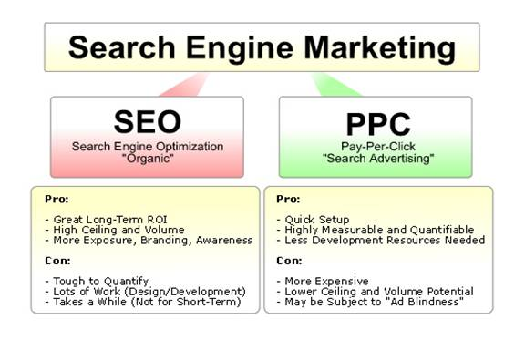](https://www.eleveratech.com/quote/)

You mostly heard the word SEO (search engine optimization) but SEM is totally different from SEO.

Search Engine Marketing is the paid marketing where you will have to pay money to Google and other search engines to show your ads in the search engine results.

Search Engine Optimization, on the other hand, refers to the organic search results where your website ranks in the SERP(search engine results page).

SEO and SEM are both very important parts of any [online marketing strategy](https://www.eleveratech.com/best-seo-practices-improve-ranking-2017-organic-seo-agency/).

SEO is the method to drive evergreen traffic at the top of the funnel (but it takes time).

On the other hand, Search Engine Advertisements are a costly method to drive traffic (Instantly) to your website.

With the increase in a number of competitors in online business, hence search engine marketing has become very important in increasing traffic and online presence.

In PPC or search engine marketing, you will only pay for the clicks only.

You can [target the specific group of people](https://support.google.com/adwords/answer/2497940?co=ADWORDS.IsAWNCustomer%3Dfalse&hl=en) on the basis of their interest as well as geographical area or you can promote a specific product or service.

This makes it very efficient for the company to spend money on Ad networks.

It may also help you to get direct traffic once the visitor familiar to your website.

The most popular search engine “Google” offer Adwords for the marketing of your online business.

Search engine marketing unlike the other methods of marketing does not interrupt the user’s web experience.

The results are very immediate with PPC or Search Engine Marketing hence it is arguably the best and quickest method to drive quality traffic to your website.

# Search Engine Marketing Plan:

[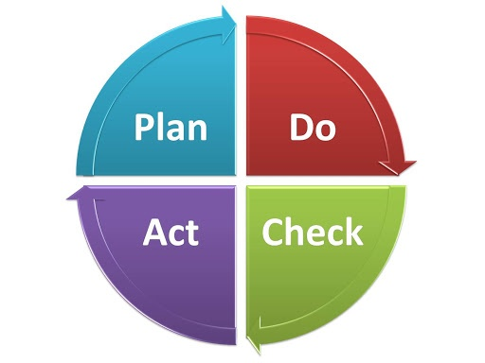](https://www.eleveratech.com/quote/)

In order to succeed in Search Engine Marketing, you should have a proper SEM plan. Here are the points you need to consider while creating a good SEM plan.

* The first thing you need to consider who is your [target audience](https://www.quicksprout.com/the-complete-guide-to-building-your-personal-brand-chapter-2/)? You should do proper research and find out where your potential customers hang out and what they want.
* You should set your goals and targets as well as the methods by which you are going to achieve that.
* Use the SEM tools which would help in maintaining a proper SEM plan. For example, keyword analysis tool [Google Adwords](https://www.quicksprout.com/the-complete-guide-to-building-your-personal-brand-chapter-2/) which would help you in determining the right keywords for your business.
* Test your keywords regularly.
* Make creative ads. To target your potential audience.
* Try to add fresh content frequently and also update the web design.
* Update your blog and RSS feed regularly.
* Finally, track your website performance using various tracking software’s available like [Google analytics](https://analytics.google.com/analytics/web/provision/?authuser=0#provision/SignUp/).

**What is Google AdWords?**

To give you the dictionary definition, Google AdWords is an online advertising service developed by Google to help marketers reach their customers instantly.

When someone searches on Google for a particular term, say ‘travel packages’, Google would throw a list of searches for you. But if you look closely, you will notice that the top and the bottom results are generally ads.

**Paid marketing terms to learn**

**Impressions:** The number of times an ad is viewed.

**Cost:** The amount of money a campaign spends on paid advertising.

**Clicks:** The number of times your ad was clicked on by a user.

**Conversion:** The specific goal you are tracking (a sale, a view of a high-value page, an email sign up, etc.).

**CPM (cost per thousand impressions):** The ad buyer’s cost to have their ad seen 1,000 times.

**CPC (cost per click)**: The ad buyer’s cost per click. CPC can be as low as a few cents or as high as a few hundred dollars, depending on competition, your industry, and audience relevance.

**Cost per conversion:** The ad buyer’s cost per purchase, order, acquired customer, or another conversion goal you’ve set.

**CTR (click-through rate):** The percentage of users who clicked on your ad out of the total number of impressions it received. Your click-through rate is the most significant signal of relevancy in Google’s search auctions.

**Conversion rate:** The number of conversions divided by the number of clicks, expressed as a percentage.

**Budget:** The total amount of money allocated to an ad campaign.

**Revenue:** The total value, in dollars, generated by an ad.

**Profit:** The total value, in dollars, generated by an ad after subtracting expenses, such as advertising costs and cost of goods.

**ROAS (return on ad spend):** Revenue generated from an ad divided by the advertising cost to show the return on that ad. For example, $5 made for every $1 spent yields a ROAS of 5:1.

**AOV (average order value):** The average dollar amount a customer spends on a site. AOV is calculated by dividing the total revenue by the number of orders.

**CLV (customer lifetime value):** The predicted total value of a single customer (sometimes called LTV) for the entirety of their relationship with a company, including future purchases.

**Terms and concepts used in Google Ads**

**Campaign:** A campaign contains a single advertising objective, such as traffic or conversions, for one or more ad groups. Budgeting is done at the campaign level and if you expect certain things within a campaign will perform differently (better or worse) that’s a good indication it should be a separate campaign.

**Ad group:** An ad group contains one or more ads and your targeting. A good ad group set up has a unique set of ad messages that directly match your targeting.

**Ad:** The creative ( text, image, video, etc.) that users will see.

**Keyword:** The phrase or word(s) a user enters into the search engine.

**Keyword match type:** Keyword match type involves controlling how broad or exact the chosen keywords (synonyms, related searches, etc.) must be to trigger an ad.

**Negative keywords:** If you want to prevent your ad from being triggered by a certain word or phrase, you would add it to your negative keywords list. This helps you exclude similar but irrelevant keywords (e.g. “apple cider” for Apple the brand).

**Quality score:** The relevancy of an ad to the search term or audience being targeted. Generally, the higher the quality score, the lower the cost per click and the better the ad position.

**Type of ads in Google AdWords**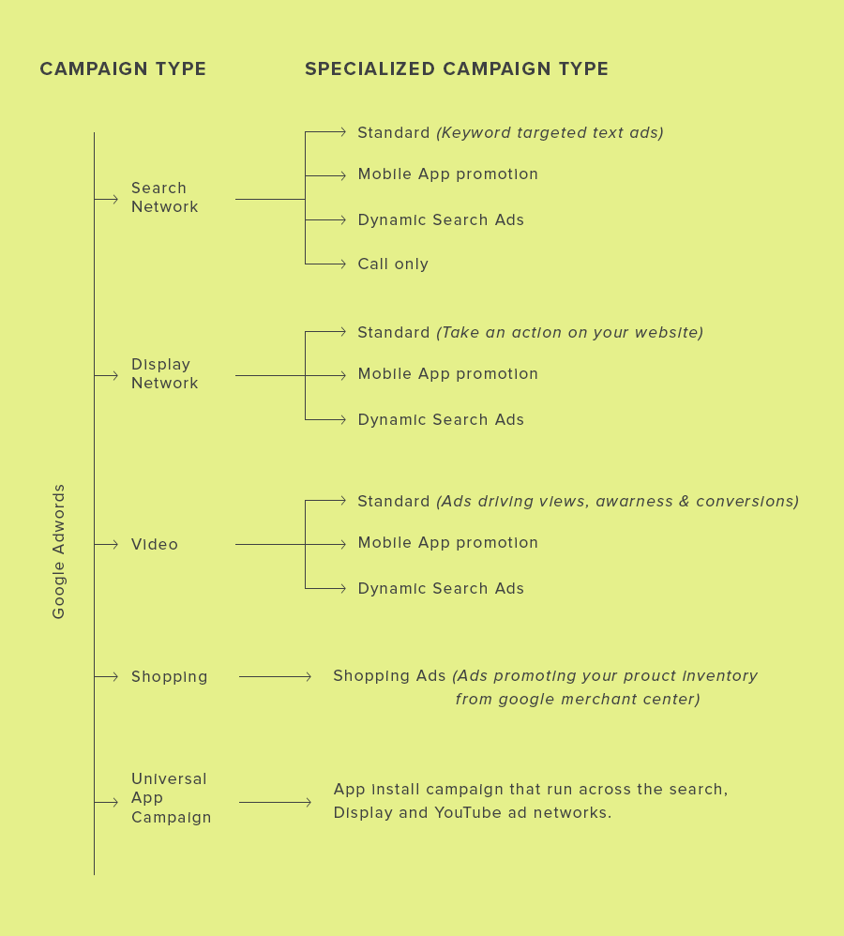

**Types of ads**

**A) Search ads**

Like my travel example earlier, when a user searches for something on Google, the list of ads that appear above the organic listing are called search ads. For example, when a user searches for “Kashmir holiday packages”, the search results will look something like this.

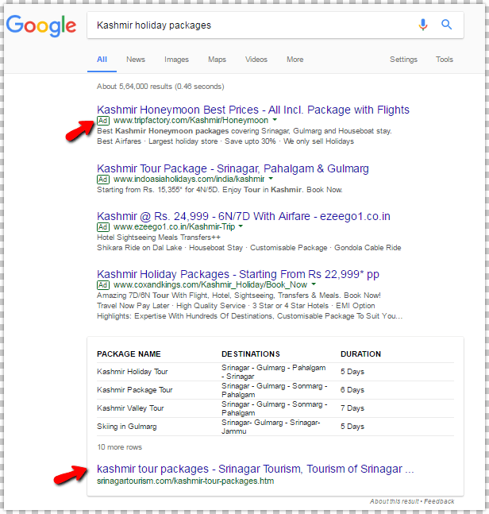

The ones marked “Ad” are ads. And, the results below that are organic.

Important factors in search ads

* Targeting – For instance, your ads will be shown in the geography that you choose (you can go as specific as the ZIP code)
* Search term and keyword – What is being searched for by the user + the keyword that you optimize the ad for.
* Ad copy relevance – Ads that appear for a specific search term should be relevant. A search for colleges should not throw results for travel packages.
* Landing page experience – How relevant is the landing page to what the searcher wanted? Did he get what he was looking for?
* Conversion rate – This is again controlled by relevance, landing page quality, and experience.
* Bids – If 2 advertisers have perfect ads and landing pages, the higher bid will get preference over the lower one.
* Quality score: Quality score again depends on all of the other factors mentioned above. So, it’s more like a cycle than everything else. Everything is interrelated.

In addition to the standard search ads, you can also run these special ads in search network.

1. Call-only ads – This ad is available only on call enabled mobile devices. After clicking the ad, instead of taking you to a landing page, you make a call directly.
2. Dynamic ads– This ad type is more suitable for businesses who have a well-managed website. This is because the content of the ad as well as the landing pages is taken dynamically from the website. They are very similar to text ads, except that no keywords are involved here. For example: a training institute is running dynamic search ads. A user searches for “java courses”. Google displays a list of ads. But dynamic ads would automatically replace the ad headline with “java course” (the search query) and the ad text with the relevant website content and landing page”.
3. Mobile app promotion- These ads are suitable for businesses with mobile applications. The goal of this ad is to encourage users to download your app or take a desired action within the app.

Note: All these special ads are available on the search network. Except for call-only ads, others are available in display and video campaigns as well. The concepts are the same, but the platforms are different.

**B) Display ads**

Have you ever noticed them? While you are reading a post or viewing a video on some random website, you see ads in a lot of different places on the page, and in different dimensions. These are display ads.

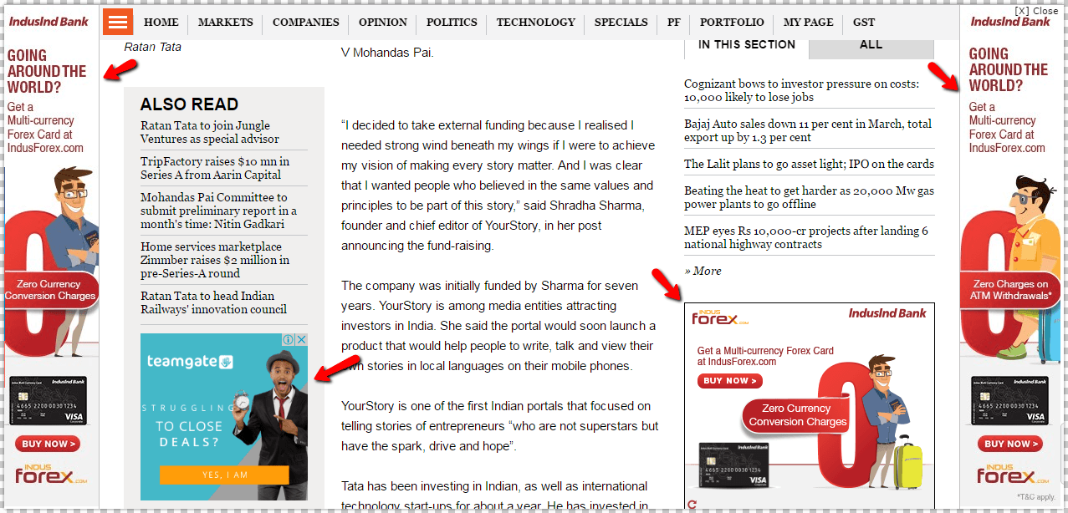

Here the searcher is not explicitly looking for what is ad offers. But, based on a number of factors like keywords, audience interest, managed placements etc, Google decides to show them to you. These display ads only appear on advertising-supported websites.

Below are the targeting criteria, based on which Google selects the websites to place the banner ads.

Keywords – The ads are displayed based on the keywords that they are optimized for. Let’s say the keyword for the ad is “Social Media Marketing”, then Google would choose websites that have content on the topic.

Placements – Placements are nothing but the websites on which you want your ad to appear. Just add the websites where you want to show the ads, instead of keywords. For example, if you want to show your ads only on travel related websites, then look for advertising supported travel sites and add them to your targeting.

Remarketing – This helps you reconnect with your existing website visitors. Using this, you can target visitors who have come to your

website but have not taken any action.

Topic – There are specific topics in AdWords, under which all websites are grouped. It will be easier for the advertisers to choose topics related to the businesses. For example, websites related to travel will be listed under the topic ‘travel.’

C) Shopping ads

If you are a retailer, this campaign type would make more sense for you. This ad type boosts traffic to your website and helps in generating quality leads as well as increasing your conversions.

This is how shopping ads would appear on the search network.

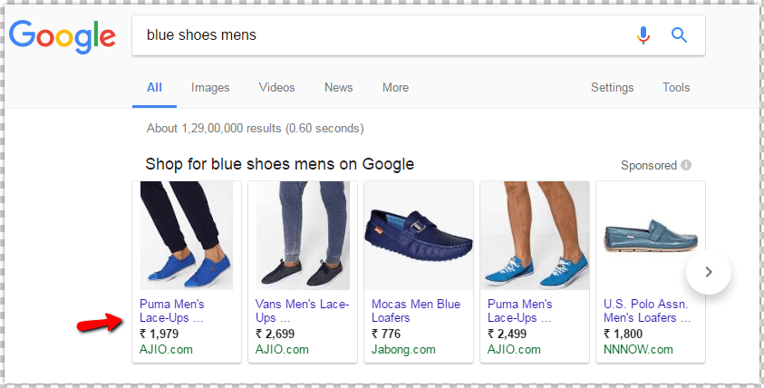

Requirements for running shopping ads:

1. Setup an account with Google Merchant Center (It is a platform that helps retailers to upload all their product listings in a specific format).
2. Setup an account with Google AdWords & link them together.
3. Submit updated product data every 30 days to Google Merchant Center.

Since both the tools are linked together, shopping ads take all the product details from Google Merchant Center, matches the search query and displays relevant ads to the user.

D) Video ads

This ad type lets advertisers run video ads on YouTube and other Google Display Networks.

The 3 main benefits of running video ads are:

1. Better targeting – This ad type has demographic, location, interest, keyword and device targeting which helps you reach the right audience on YouTube and Google Display Network.
2. More reach – As of January 2017, YouTube is the 3rd most visited website and has 30 million visitors every day. Additionally, video ads are also available on Google Display Network. This means that you have access to a wider audience.
3. Measurable – Unlike advertising on TV, YouTube ads let you know all the necessary metrics like views, view rate, clicks, reach and frequency, engagement, performance etc. This helps you measure the success of video ads.

Example: video ad from Grammarly

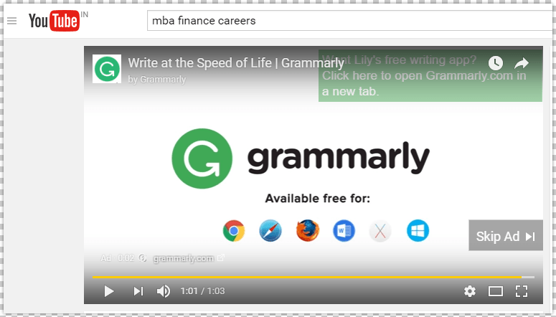

E) Universal app campaign

This campaign is helpful for businesses with a mobile app. Here, the advertiser can promote the mobile app across search, PlayStore, Display & YouTube. AdWords uses ad text ideas and other assets right from your app store listings. All you need to do is provide some text, a budget. and a starting bid. Also, don’t forget to set languages and locations for the ad.

By utilizing all this information, AdWords itself designs a variety of ads in different formats. Google will automatically test different ad combinations and display the one that performs the best.

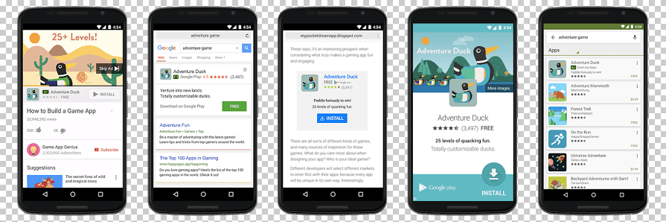

Google Ads (Adwords) Campaign Types

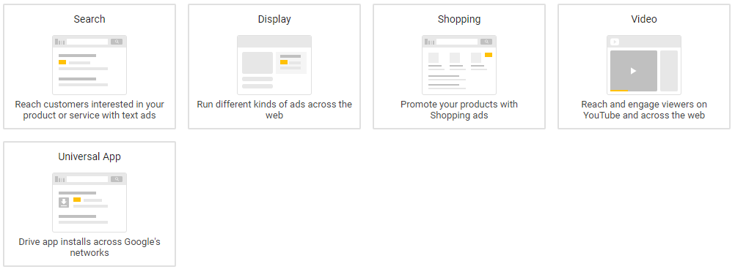

Google Ads (Adwords) allows to choose between Five different campaign types. They are: Search Network, Display Network, Video (YouTube), Shopping, and Universal Apps. Choosing a campaign type is the first step in getting ads running. Each campaign type has secondary features that expand and contract the functionality in the campaign (e.g. Standard, All Features, Mobile app installs, Dynamic Search Ads, Call-only, Marketing Objectives, etc.).

**1) Search Network**

Search Network (SN) only campaigns allow you to show text ads on the search engine result pages only. Campaign features are more extensive than SNDS, and besides “Standard” and “All Features” they include Mobile app installs, Mobile app engagement, Dynamic Search Ads, and Call-only. “Standard” features are a good bet for new Google Ads users in this case as well, as the features includes five extensions. The Search Network is a great place to advertise for a wide range of businesses, and it’s particularly good for local businesses.

When should you use the SN?

* Any budget
* Appropriate choice for most businesses
* If you want to advertise on Google Maps
* If you want to pay to be #1 on Google

**2) Display Network**

Known for displaying image ads, the Display Network (DN) contains over a million websites to show ads on (managed placements). The features are slightly different for the DN and start with “Marketing objectives” or “No marketing objective.” If you select “Marketing objectives,” you’ll be able to build your campaign based on awareness (impressions), influence (visits, engagement), or actions (buy, call, visit a location). As you select from one of these three boxes you will change the features on the page that relate best to building that type of campaign.

When should you use the DN?

* For building brand awareness
* If you have certain website you want to advertise on
* To create remarketing campaigns
* If you want to display ads on YouTube

**3) Video (YouTube)**

Advertise on YouTube with Video campaigns on Google Adwords. You can choose ad formats that serve with an option to skip the ad after five seconds or as a six second buffer between videos. Campaign features allow you to extend ads with shopping campaigns and with mobile app installs. Campaign setting are straight forward here, but there are a few options to select to get started.

When should you use Video campaigns?

* For creating placing your commercial video content on YouTube
* If you have video content you want to promote

**4) Shopping**

Google Shopping ads don’t have much setup and there aren’t many features to select. If you want to show products from your eCommerce store in Google Shopping, then you’ll need to setup the Google Merchant Center. While the process is not difficult, there can be roadblocks depending on how your eCommerce store is setup. If Google Merchant Center is setup and receiving your store’s feed, hook it up to your new Shopping campaign and Google will do the rest — no need to target or create ads.

When should you use Google Shopping?

* If you have an eCommerce store

**5) Universal App Campaign**

Easily advertise your app across Search, Display, and Video Networks with the Universal App Campaign. This is the best place to setup advertising for your app because of Google’s reach. Setup is straight forward in this campaign as well, although you will need to add your app and modify your objectives.

When should you use Universal App Campaign?

* If you have a new or existing app
* If you want to drive in app sales

**Campaign Settings**

**Campaign Name:** This is where you enter a name for your campaign. Although Google Ads enters a default campaign name for you, you may rename it so that you can easily find it in your account. Your campaign name isn’t visible to your customers.

Campaign type that you choose tailors the campaign set-up to what’s appropriate for your goals. If you tell Google Ads your advertising goals, you’ll see relevant suggestions over time based on the goals that you select.

**Networks:** The Networks setting indicates where you want your ad to appear based on the campaign type that you chose. For example, with the Google Search Network, your ad can appear on Google search sites and non-Google search sites (such as CNN) that partner with Google to show search ads, called search partners.

**Devices:** Campaigns target all types of devices, including desktops, tablets, and mobile devices. Later, you can choose to customize ads for different devices.

**Locations & Languages:** Your campaign’s ads are eligible to show to customers in your targeted geographic locations, or to customers who have selected your targeted language as their browser’s language setting. We recommend choosing the language that you serve your customers in.

**Biding & Budget:** Choose to manually set your bids for clicks on your ads or let Google Ads do it for you. Depending on your campaign type, you may see additional bidding options to choose from.

Your bid strategy controls how you pay for users to interact with your ads. Your bid limit is the most that you’ll pay per click for ads in an ad group. Your budget is the average amount that you’re comfortable spending each day on your campaign. The budget that you choose is entirely up to you, and you can adjust it at any time.

**Ad Extensions:** Include even more information with your ads, such as location information, links to pages on your website, and your phone number.

**Additional Settings:** optional features to optimize your campaign:

Schedule: Set a campaign start and end date

Ad scheduling: Choose certain days or hours of the week for your ads to show

Ad delivery: By default, Google Ads shows your ads when they’re more likely to get clicks or conversions, but you can choose to show your ads more evenly throughout the day

Advanced location options

Campaign URL options

With the Google Display Network, your ad is displayed on other sites that partner with Google to show ads.

**What is automated bidding?**

Automated bidding is a Google Ads bid strategy designed to maximize results based on your set campaign goals. With automated bidding, Google automatically sets bid amounts based on the likelihood that your ad will result in a click or conversion. To do this, they analyze data such as a user’s device, operating system, the time of day they are searching, demographics, and location.

All of Google’s automated bid strategies are **portfolio bid strategies** (an automated, goal-driven bid strategy that groups multiple campaigns, ad groups, and keywords). This means that advertisers can apply their chosen strategy across all of their campaigns, ad groups, and keywords. Some are available as **standard strategies** (an ad strategy that can be used in single campaigns).

Automated bidding aims to solve two concerns that advertisers often face their campaigns:

* Whether or not their bids are high enough to compete for qualified buyers.
* Whether or not their bids are too high and possibly showing to people who have no interest in making a purchase.

By automating bids, there’s no need to update bids for keywords or ad groups manually. Bids are set automatically and are unique to each auction (the bid will be different for every auction).

Automated bid strategies analyze past data and learn over time, using performance to inform future bids. This performance is another indication of Google’s movement towards machine learning, which is also used by their Universal App Campaigns.

Finally, automated bids are available for both Search and Display ads depending on the bid strategy you are using.

**What is Smart Bidding?**

Smart Bidding is simply an automated bid category that includes only conversion-based strategies. Smart Bidding uses machine learning to maximize conversion results by tracking and analyzing data signals from every search and click. Using this data, Google will either increase or decrease bids based on whether or not it believes a click will result in a conversion. For example, it will set a higher bid for a searcher who is more likely to make a purchase.

There are currently four Smart Bidding strategies:

1. Enhanced CPC
2. Target CPA
3. Target ROAS
4. Maximize Conversions

**Requirements and recommendations**

To use Smart Bidding, you must have conversion tracking enabled (unless you are using Enhanced CPC with Display campaigns). Additionally, Google recommends that advertisers have at least 30 conversions in the past 30 days before using Target CPA and at least 50 conversions before using Target ROAS.

**The 7 types of automated bidding strategies**

There are seven different automated bid strategies:

**1. Maximize clicks**

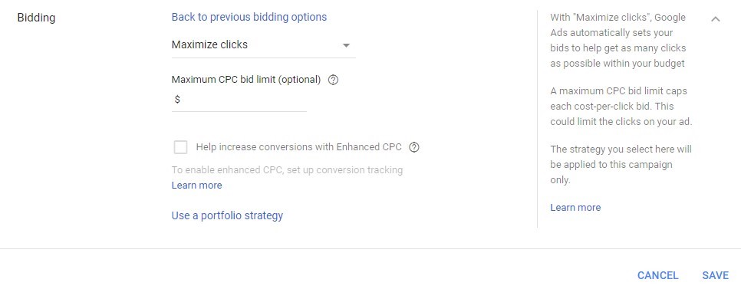

**Goal:** Increase site visits

**Available In:** Single campaigns or across multiple campaigns, ad groups, and keywords

**Description:** The Maximize Clicks strategy aims to increase the number of visitors to your site. The strategy automatically sets bids to help you maximize clicks within your set budget. The strategy is available as a standard strategy in a single campaign or a portfolio bid strategy across multiple campaigns, ad groups, and keywords.

**Best Used When:** You have a solid conversion funnel and you want to send as many visitors to your website as possible.

**2. Target search page location**

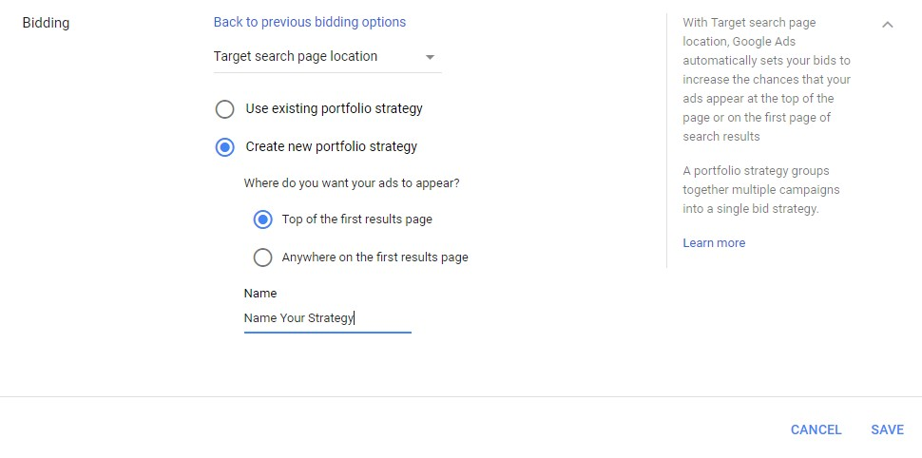

**Goal:** Increase visibility on the first page of a Google search results page or show in one of the top positions

**Available In:** Campaigns

**Description:** Target Search Page Location automatically sets bids to help increase the chance that your ads appear on the first page of a Google search or in one of the top ad positions. It is only available as a portfolio bid strategy on the Search Network.

**Best Used When:** You want to rank as one of the top positions in a Google search.

**3. Target outranking share**

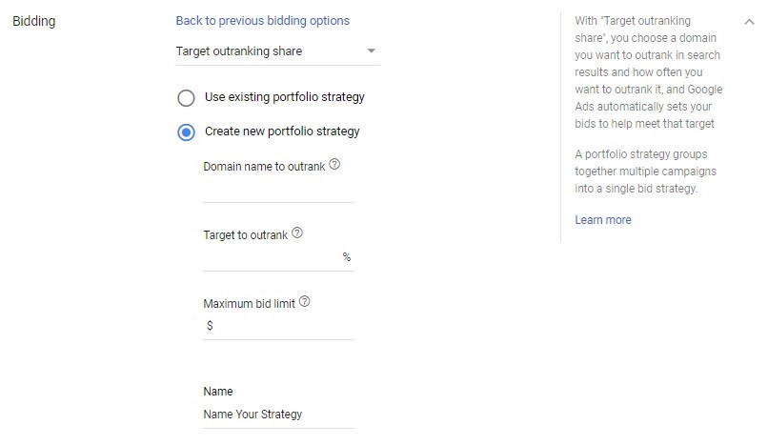

**Goal:** Increase visibility over other websites

**Available In**: Campaigns

**Description**: With Target Outranking Share, you can choose another advertiser’s domain that you want to outrank in ad position and how often you’d like to outrank it. Google will then automatically set your search bids to help meet that objective. Target Outranking Share is only available as a portfolio bid strategy.

**Best Used When**: You want to outrank a specific competitor in your industry.

**4. Target cost-per-acquisition (CPA)**

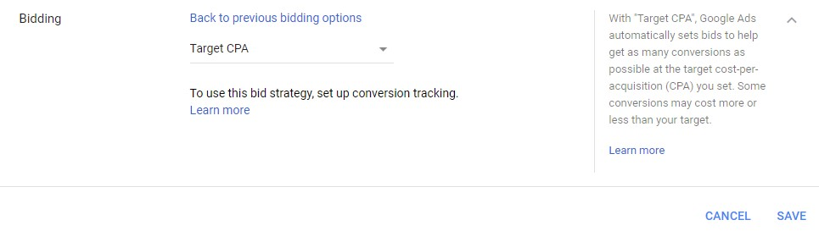

**Goal:** Get more conversions with your target CPA

**Available In:** Campaigns and ad groups

**Description:** Target CPA allows for more control over your automated bidding. With the strategy, Google automatically sets Search or Display bids to help you receive as many conversions as possible at your set target cost-per-acquisition (CPA). Some conversions may cost more or less than your target. Target CPA bidding is available as a standard strategy in a single campaign or as a portfolio bid strategy across multiple campaigns and ad groups.

**Best Used When:** You’ve established a CPA that you know you can spend to acquire a customer while still maintaining a profit.

**5. Enhanced cost-per-click (ECPC)**

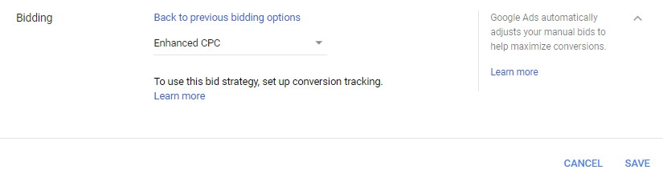

**Goal:** Increase conversions while staying in control of your keyword bids

**Available In:** Campaigns, ad groups, keywords

**Description**: With ECPC, Google automatically adjusts your manual bids to help you generate more conversions while trying to achieve the same cost-per-conversion. ECPC is available as an optional feature when using Manual CPC bidding or as a portfolio bid strategy.

**Best Used When:** You are using a manual bidding strategy but still want to take advantage of automated bidding.

**6. Target return on ad spend (ROAS)**

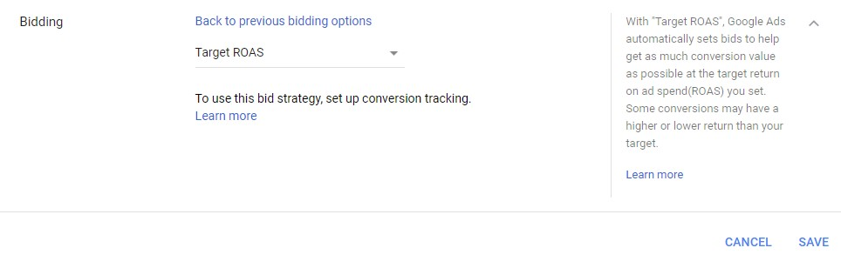

**Goal:** Meet a target return on ad spend (ROAS) when you value each conversion differently

**Available In:** Campaigns, ad groups, keywords

**Description:** Target ROAS automatically sets your bids to help you receive as much conversion value as possible at your set ROAS (the average value you receive in turn for every dollar you spend on ads). Some conversions may have a higher or lower return than your target. Target ROAS is available as a portfolio bid strategy and a standard strategy for individual campaigns.

**Best Used When:** You want to focus efforts on driving the highest value of conversions versus trying to receive the highest number of conversions.

**7. Maximize conversions**

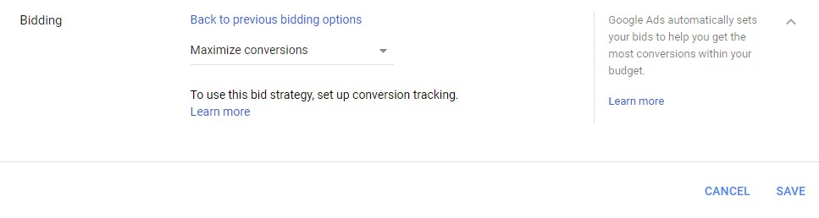

**Goal:** Receive more conversions while spending your budget

**Available In:** Campaigns

**Description:** This strategy automatically sets bids to help you receive the most conversions for your campaigns while spending your entire budget. With this strategy, Google optimizes for a higher volume of conversions. Maximize Conversions is available as a standard strategy for individual campaigns, but not as a portfolio bid strategy.

**Best Used When:** You have a large budget and want to automate your ads to drive more conversions.

**Types of automated bid strategies**

|  |  |
| --- | --- |
| **Goal** | **Bid strategy** |
| Increase site visits. | Maximize Clicks automatically sets your bids to help get as many clicks as possible within your budget.  Maximize Clicks is available as either a standard strategy in a single campaign or portfolio bid strategy across multiple campaigns.  Learn more about [Maximize Clicks](https://support.google.com/google-ads/answer/6268626).  Learn more about [Maximize Clicks for Shopping campaigns](https://support.google.com/google-ads/answer/6309038). |
| Increase visibility. | Target Impression Share automatically sets bids with the goal of showing your ad on the absolute top of the page, on the top of the page, or anywhere on the page of Google search results.  Target Impression Share is available on the Search Network only, as either a standard strategy in a single campaign or portfolio bid strategy across multiple campaigns.  Learn more about [Target Impression Share](https://support.google.com/google-ads/answer/9121108). |
| Get more conversions with your target CPA. | Target CPA automatically sets Search or Display bids to help get as many conversions as possible at the target cost-per-action (CPA) you set. Some conversions may cost more or less than your target.  Target CPA bidding is available as either a standard strategy in a single campaign or portfolio bid strategy across multiple campaigns and ad groups.  Target CPA bidding was previously referred to as “Conversion Optimizer.”  Learn more about [Target CPA](https://support.google.com/google-ads/answer/6268632). |
| Meet a target return on ad spend (ROAS) when you value each conversion differently. | Target ROAS automatically sets bids to help get as much conversion value as possible at the target return on ad spend (ROAS) you set. Some conversions may have a higher or lower return than your target.  It's available as a portfolio bid strategy and a standard strategy for individual campaigns.  Learn more about [Target ROAS](https://support.google.com/google-ads/answer/6268637).  Learn more about [Target ROAS for Shopping campaigns](https://support.google.com/google-ads/answer/6309035). |
| Get more conversions while spending your budget. | Maximize Conversions automatically sets bids to help you get the most conversions for your campaign while spending your budget.  It's available as a standard strategy for individual campaigns, but not as a portfolio bid strategy.  Learn more about [Maximize Conversions](https://support.google.com/google-ads/answer/7381968). |

**Benefits and disadvantages of automated bidding**

Before you implement any automated bidding strategy, you should weigh the benefits and disadvantages equally:

**Benefits**

Since bids are set automatically, you’ll save time by not having to manually set bid amounts for ad groups or individual keywords.

Automated bidding uses machine learning to evaluate performance over time and optimize for your specific goal. Thus, in theory, you should see more conversions or clicks for your ads based on your set goal.

**Disadvantages**

Since Google will make optimizations on the spot, advertisers should expect drastic changes from time to time (e.g., a much higher bid than expected). Because of this, automated bidding is best suited for companies with a flexible and/or large advertising budget.

Google’s automated bidding requires historical data to optimize for your set goal and predict future bids. Therefore, for companies just getting started using Google Ads, automated bidding might not be the best strategy.

While bidding itself is automated, you still need to monitor your campaigns to evaluate if the bid strategy is meeting your desired goal.

**Manual CPC Bidding**

A bidding method that lets to set your own maximum cost-per-click for(CPC) for your ads. This differs from automated bid strategies, which sets bid amounts for you.

<https://blog.tryadhawk.com/google-adwords/ultimate-automated-bid-strategy-guide/>

<https://www.disruptiveadvertising.com/adwords/automated-bidding-strategies/>